
SYMBIOSIS INSTITUTE OF TECHNOLOGY, PUNE
Symbiosis International (Deemed University)
(Established under section 3 of the UGC Act, 1956)
Re-accredited by NAAC with ‘A’ grade (3.58/4) | Awarded Category – I by UGC
Founder: Prof. Dr. S. B. Mujumdar, M. Sc., Ph. D. (Awarded Padma Bhushan and Padma Shri by President of India)

Assignment No. 03

Subject: | DevOps Lab
TCODE: | TE7950
Name of Student | Yash Patel
PRN No. | 23070122235
Branch | CSE, Batch (2023-27), L4
Academic Year &  Semester | 25 – 26, Sem VII
Date of Performance | 16th July, 2026
Title of Assignment: | Simulating Git Collaboration & Conflict Resolution
Theory: | Git collaboration allows multiple developers to work on the same project simultaneously using separate branches. When different branches modify the same part of a file, Git cannot automatically combine the changes and reports a merge conflict. The conflict must be resolved manually by editing the affected file, removing the conflict markers, and selecting the final version of the content. After resolving the conflict, the changes are staged, committed, and pushed to the remote repository. This process ensures that all changes are correctly integrated while maintaining the project's history.  Commands Used  - git checkout main – Switched to the main branch before starting the experiment.  - git status – Verified that the working tree was clean and the main branch was up to date.  - git checkout -b conflicting-feature – Created a new branch named conflicting-feature and switched to it.  - Modified the README.md file and changed the first line on the conflicting-feature branch.  - git add README.md – Staged the modified README.md file on the feature branch.  - git commit -m "Update README first line on feature branch" – Committed the changes made on the conflicting-feature branch.  - git checkout main – Switched back to the main branch.  - Modified the same first line of the README.md file differently on the main branch.  - git add README.md – Staged the modified file on the main branch.  - git commit -m "Update README first line on main" – Committed the changes on the main branch.  - git merge conflicting-feature – Attempted to merge the conflicting-feature branch into the main branch, resulting in a merge conflict.  - git status – Verified the conflict by checking that README.md appeared under Unmerged paths.  - Manually edited the README.md file to remove the conflict markers and resolve the conflict.  - git add README.md – Staged the resolved file after resolving the merge conflict.  - git status – Confirmed that all conflicts were fixed and the repository was ready for the merge commit.  - git commit -m "Merge conflicting-feature, resolve README conflict" – Completed the merge by creating a merge commit after resolving the conflict.  - git push origin main – Pushed the resolved merge commit from the local main branch to the remote GitHub repository.
Implementation: | Step 1: Verify Current Repository Status  Verified Repository Status — Confirmed that the repository was on the main branch with a clean working tree before creating the conflicting branch.  Step 2: Create and Switch to a New Branch  Created Conflicting Branch — Created a new branch named conflicting-feature from the current state of the main branch.  Step 3: Modify README.md on the Feature Branch  Updated Feature Branch — Modified the first line of README.md on the conflicting-feature branch and committed the changes.  Step 4: Switch Back to Main and Make a Different Change  Updated Main Branch — Switched back to the main branch, modified the same line differently, and committed the changes.  Step 5: Merge the Branch  Merge Conflict — Attempted to merge the conflicting-feature branch into main, resulting in a merge conflict because both branches modified the same line.  Step 6: Verify the Conflict  Conflict Verified — Confirmed the merge conflict using git status, which displayed README.md under Unmerged paths.  Step 7: Resolve the Conflict  Conflict Resolved — Manually removed the conflict markers and edited the file to create the final merged version.  Step 8: Stage the Resolved File  Resolved File Staged — Staged the resolved file and confirmed that all merge conflicts had been fixed.  Step 9: Complete the MergeMerge Completed — Completed the merge by creating a merge commit that combines the histories of the main and conflicting-feature branches after resolving the conflict.  Step 10: Push to GitHub  Pushed to GitHub — Uploaded the resolved merge commit to the remote GitHub repository.  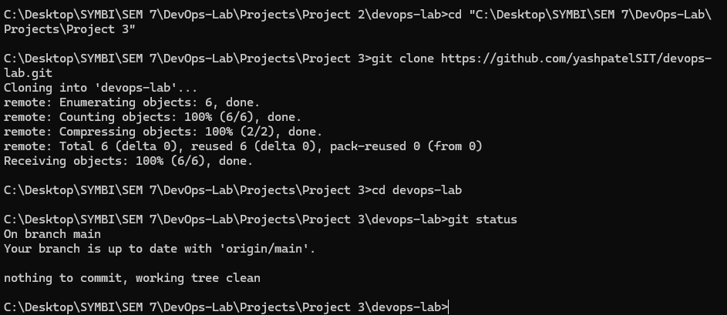  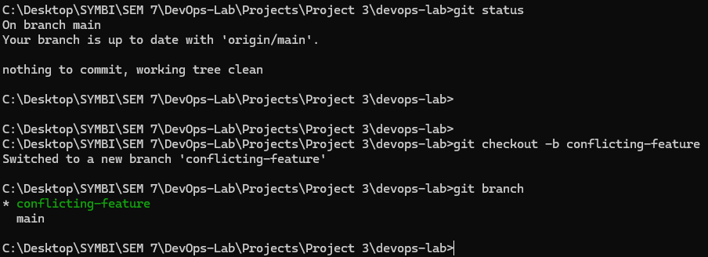  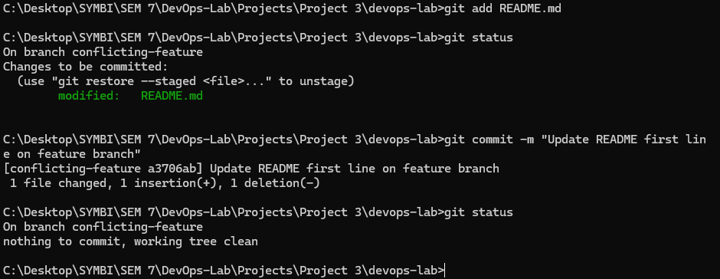  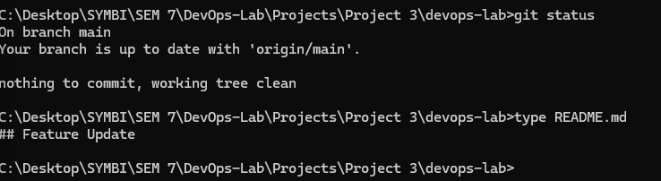  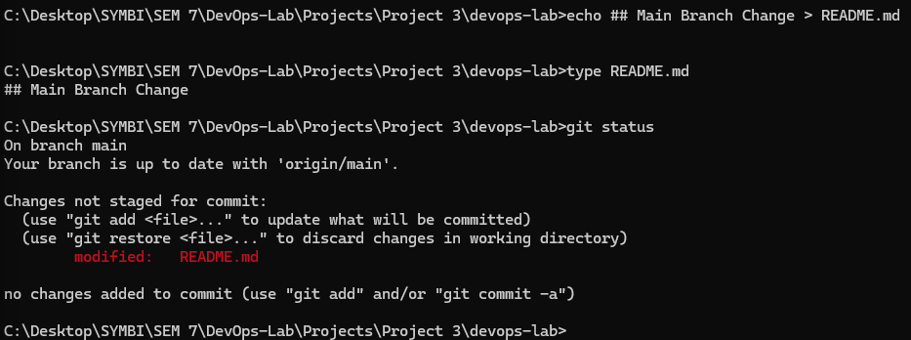  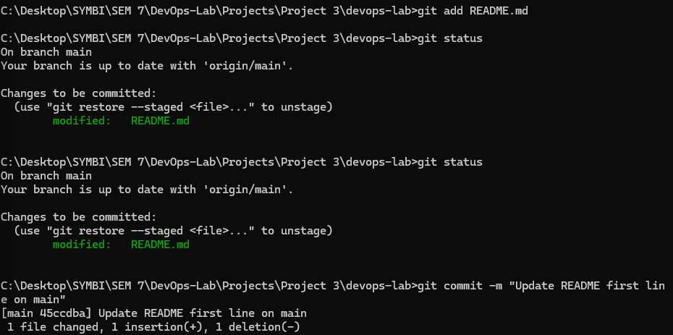  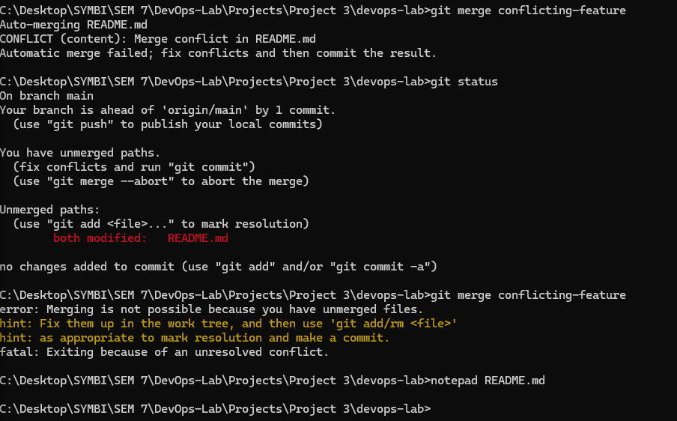  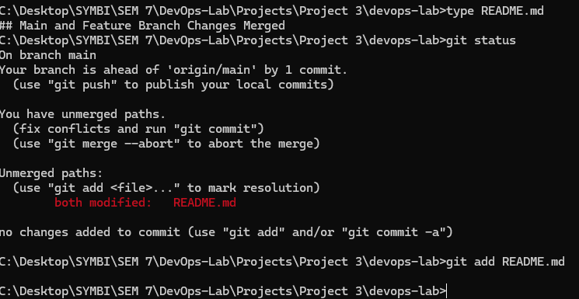  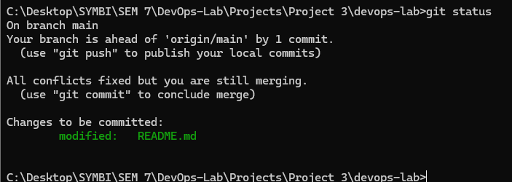  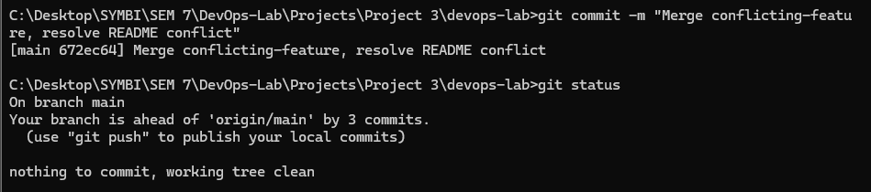  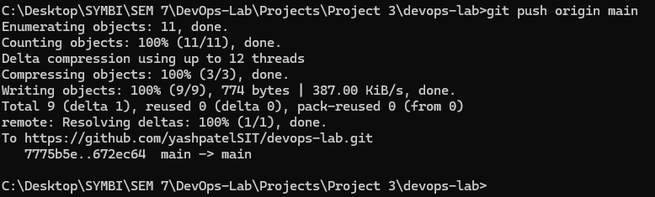  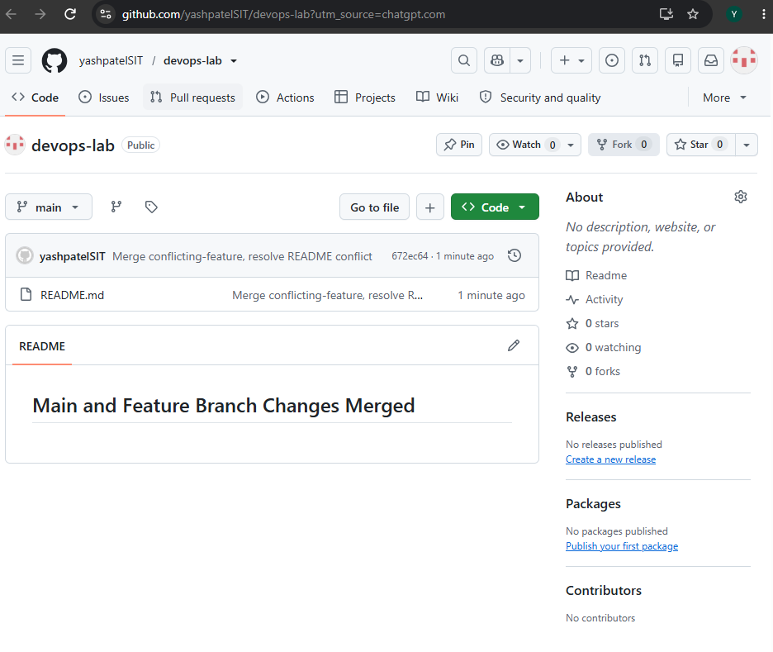

Subject Faculty Name: Prof. Arijit Dutta

